Fitflex
Fitness Application Documentation
Team:
Name | Email id
TAMILSELVI M (Team leader) | mtamilselvi2904@gmail.com
DIVYADHARSHINI V (Team member) | vdharshini226@gmail.com
SHOWJANYA S (Team member) | sowji01102004@gmail.com
MEHARAJ BEE N (Team member) | meharajbee956@gmail.com

Introduction:
FitFlex: Your Personal Fitness Companion

FitFlex is a revolutionary fitness app designed to transform workout experiences. It offers an intuitive interface, dynamic search, and a vast library of exercises for all fitness levels.
FitFlex helps users embark on a personalized fitness journey and achieve their wellness goals.
FitFlex is more than just a fitness app; it’s your personal workout companion. Built with React.js, it’s designed to cater to both beginners and seasoned fitness enthusiasts by simplifying the process of discovering, managing, and tracking workouts. With its advanced search features and visually rich content, FitFlex transforms the way users approach fitness—making it both engaging and effective.

Features:
Exercise Database: Fetches exercises from the Fitness API.
Category-based Workout Search: Users can browse exercises by equipment, body parts, or muscle groups.
Workout Details Page: Displays exercise descriptions, images, targeted muscle groups, difficulty levels, and tutorial videos.
User-Friendly Interface:Modern design with clear navigation.
Advanced Search Feature: Allows users to find workouts based on fitness preferences.
YouTube Integration:Fetches related workout videos for better guidance.

Technical Architecture:
Frontend: React.js
Backend: Rapid API for fetching exercise and fitness data.
Styling: Tailwind CSS / Bootstrap for UI design.
Routing:React Router Dom for navigation.
API Integration: Axios for making API calls to fetch workouts and exercises.
Project Goals and Objectives:
- User-Friendly Experience: Simplify navigation to help users discover, save, and share workout routines effortlessly.
- Comprehensive Exercise Management: Enable robust organization and management of exercise routines.
- Technology Stack: Use React.js with Rapid API for a seamless and responsive user experience.

Project Flow:
- Home: Showcases trending workouts.
- Search: Allows keyword-based exploration.
- Category Page: Lists exercises by category.
- Exercise Page: Displays detailed information about each exercise.

Data flow :
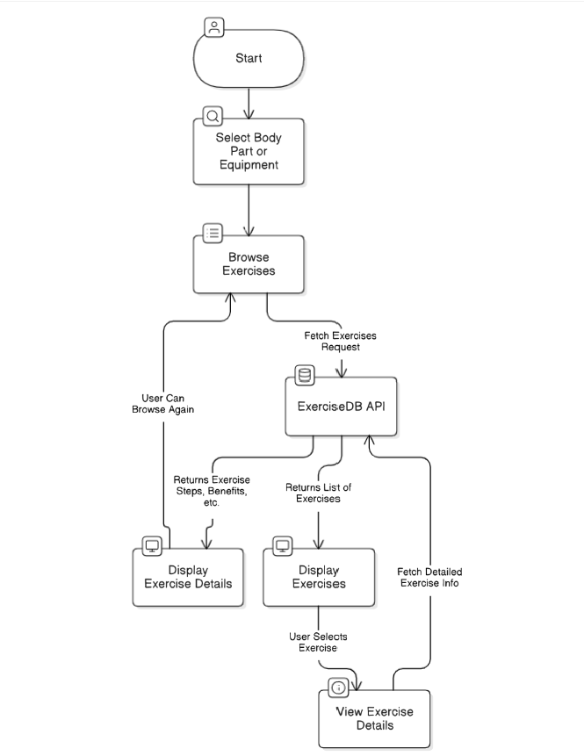
Project Structure:
fitness-app-react
├── public
├── src
│ ├── components # Reusable components (Navbar, Hero, etc.)
│ ├── pages # Different pages (Home, Exercise, Category)
│ ├── styles # CSS files
│ ├── App.js # Main component
│ ├── index.js # Entry point
├── package.json

Best Practices:
- Component-Based Structure:
Build reusable and modular components to simplify maintenance and scalability.
- API Key Management:
Store API keys securely using environment variables (.env file).
- Version Control:
Using Git for tracking changes and collaboration.
Create separate branches for new features or bug fixes

Project Screenshots:
1. Hero Component: Showcases trending workouts.

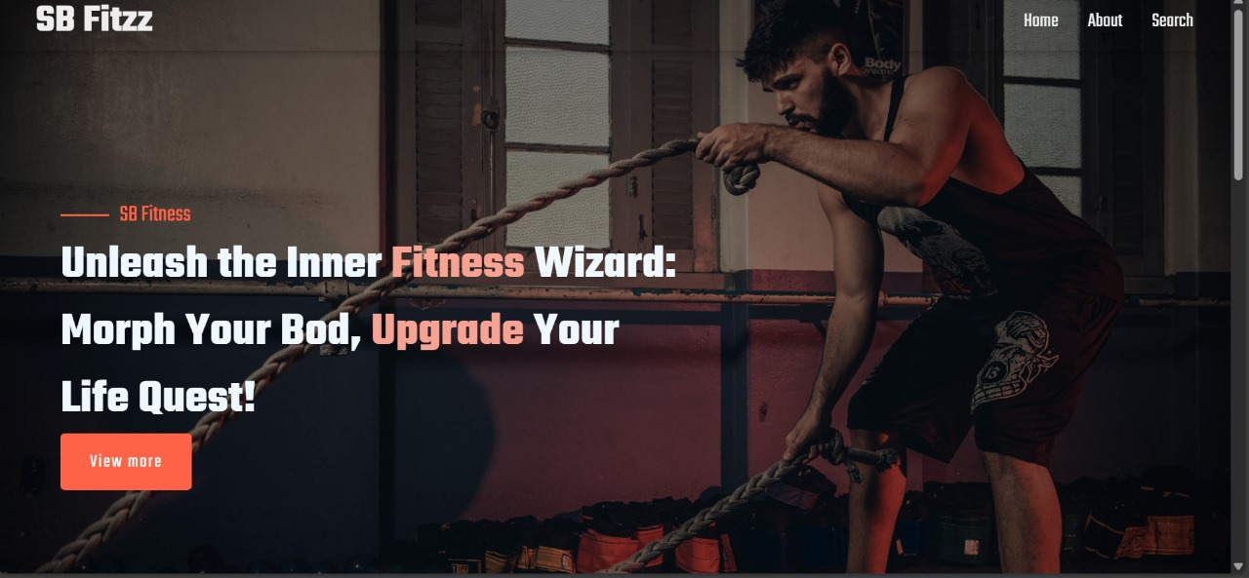

2. Search Feature: Enables users to find exercises based on keywords, body parts, or equipment.
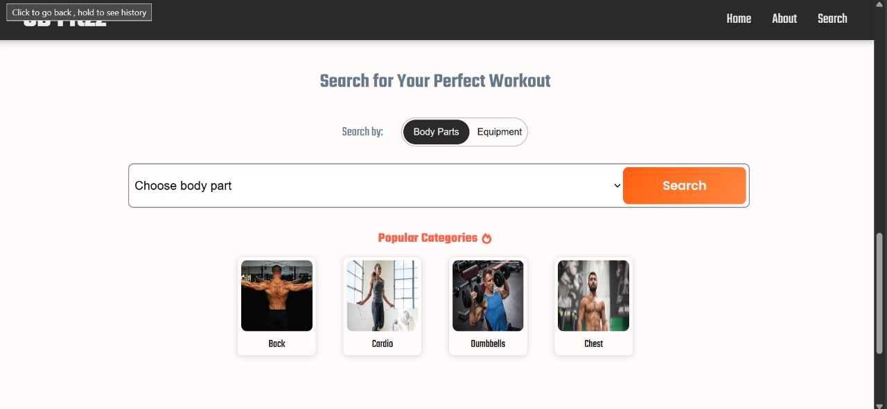

3. Category Page: Displays different exercise types.

4. Exercise Page: Provides workout details, images, and videos.

Resources and References
- React Documentation
- Rapid API Guide
- Tailwind CSS

